1) Na pesquisa do Windows, busque o Pycharm Community Edition e abra.
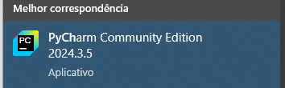

2) No terminal, digite streamlit run dash/dashboard.py e dê enter

